

Unit 1 Specialist Mathematics Investigation 1 2023 Take-home part

Student name: Teacher name:

**Task type:** Investigation take-home part

# Validation test information:

**Test date:** Tuesday 21st March (Week 8) during your usual Specialist period

**Test venue:** Your usual Specialist classroom

**Reading Time:** 5 minutes

**Working Time:** 40 minutes

**Materials required:** Calculator with CAS capability (to be provided by the student)

**Standard items:** Pens (blue/black preferred), pencils (including coloured), sharpener, correction fluid/tape, eraser, ruler, highlighters

**Special items:** Drawing instruments, templates, notes on two unfolded A4 pages of paper, and up to three calculators approved for use in the WACE examinations

# Task weighting: 10 %

**Formula sheet provided:** No, but relevant formulae stated on page 2 of validation test

# Note: All part questions worth more than 2 marks require working to obtain full marks.

Read the following, and answer the questions in the text.

You are a mathematical inventor, and you have just come up with a wonderful new mathematical machine! This machine is able to rearrange sequences of 𝑛 letters, and you have decided to call it an 𝑛-*permutator*. An example of a 7-permutator is below:

1 2 3 4 5 6 7

ቀ ቁ

3 6 2 4 7 1 5

It works as follows. Suppose you have a sequence of seven letters:

A B C D E F G

For each number 𝑖 in the top row of the 7-permutator, the letter in position 𝑖 gets moved to the position indicated by the number underneath 𝑖. So the letter A gets moved from position 1 to position 3, B from position 2 to position 6, etc. After the permutator above is applied to all of the letters, the new arrangement looks like this:

F C A D G B E

Soon, word gets around about your magnificent invention – and people start asking you for help!

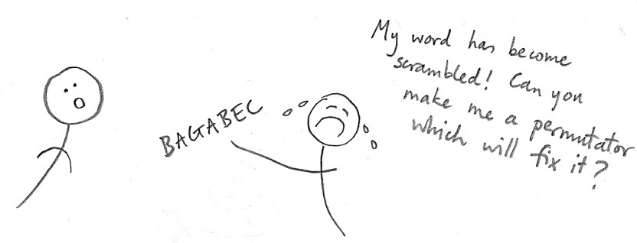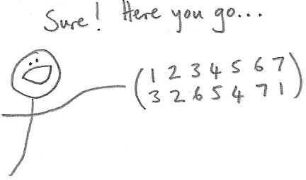

As more and more people come to you with scrambled words that need restoring, you begin to realise that your invention may have some business potential! You decide to pitch your idea to some investors. But you feel that before doing so, it would be prudent to do some investigation and research about 𝑛-permutators and their properties. (Luckily, having recently studied counting techniques in the Year 11 Specialist course, you are well-prepared for the task.)

To start with, you focus on the case with 𝑛 = 7. An obvious first question is:

1. What is the total number of different 7-permutators?

You’ve noticed that very often, people come to you with a word that has just two letters swapped, and so require an 𝑛-permutator that swaps those two letters back again. So next you try to answer the following question:

1. How many different 7-permutators swap the letters within just one pair (and leave all the other letters in the same place)?

Some further questions which occur to you are the following:

1. How many different 7-permutators swap letters within exactly 2 pairs?

How many swap letters within 3 pairs (always leaving the other letters in the same place)?

1. How many different 7-permutators move *exactly* 3 letters (leaving the other letters where they are)?

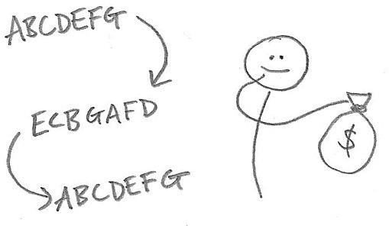Having crunched these numbers, you present your idea to some investors. One of them is very interested, but has a question:

“It seems that some 𝑛-permutators offer better value for money than others. For instance, the following 7- permutator returns all letters to their starting positions after just two applications:

1 2 3 4 5 6 7

ቀ ቁ

5 3 2 7 1 6 4

But the one below can be applied *seven* times before the order is the same as it was originally:

1 2 3 4 5 6 7

ቀ ቁ

2 3 4 5 6 7 1



This is because it rotates the seven letters around in a cycle – it’s like seven permutators in one! I’d like to know more about these ‘high value’ permutators before I stump up the cash!”

In order to investigate this, you make a new definition:

**Definition**: the *loop length* of a given 𝑛-permutator is the minimum number of times (greater than 0) that it must be applied to a sequence of 𝑛 distinct letters in order to return them all to their original positions.

The potential investor would like answers to the following questions:

1. Can you find examples of 7-permutators which have loop lengths of 3, 4, 5 and 6?
2. Are there ‘different ways’ of obtaining 7-permutators with a given loop length (such as 6)?
3. What is the total number of 7-permutators with a loop length of 7?
4. What is the total number of 7-permutators with a loop length of 5?
5. What is the maximum possible loop length of a 7-permutator?

Having figured out answers to these questions, you tell the potential investor, who says:

“I’m very impressed. But there’s one more thing I’d like to know. So far you’ve told me all about 𝑛- permutators with 𝑛 = 7. I presume most people won’t have need of an 𝑛-permutator with 𝑛 more than about 15. I’d like to know if the methods for answering these questions can be generalised for values of 𝑛 up to 15. Can you investigate please?”